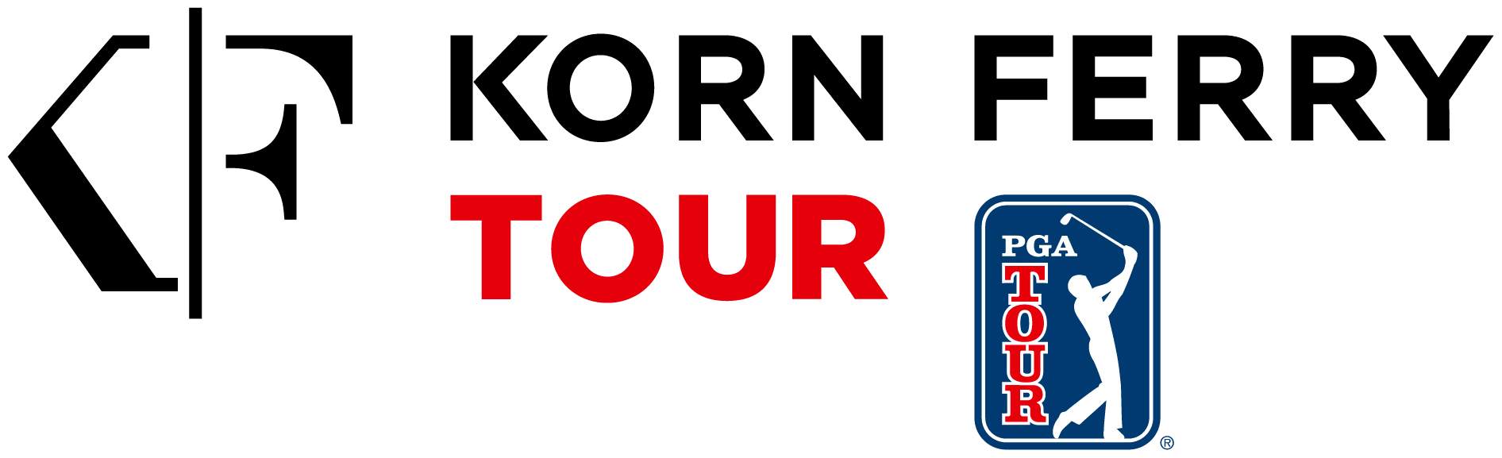
CADDIE MEETING
Club Car Championship at The Landings Golf & Athletic Club
When:
Tuesday, April 1 at 3:00 pm
Where:
Hitting Bays within Caddie HQ
Agenda:
The Rules staff will present details pertaining to the Revised Pace of Play Policy and the use of Distance Measuring Devices going into effect at the LECOM Suncoast Classic. This will be an open forum and should last around 30 minutes.

